Retail Application

I have developed this application into .Net MVC with Entity framwork.

Following are the Database details

Database Name : Retail

Tables :

1. Emp_details: To store employee details (EmployeeID,Employee Name, Address and Mobile number)
2. WorkShifts: To maintain shifts of employee and the break timing and hourly pay ( ID, Shifts, minibreak, longbreak, per_hr_pay)
3. Revenue_details: To maintain employees work hrs and pay (ID, EmployeeID, Shifts, Date, hrs_worked,Revenue)

Following are the application module details.

1. Add Employee

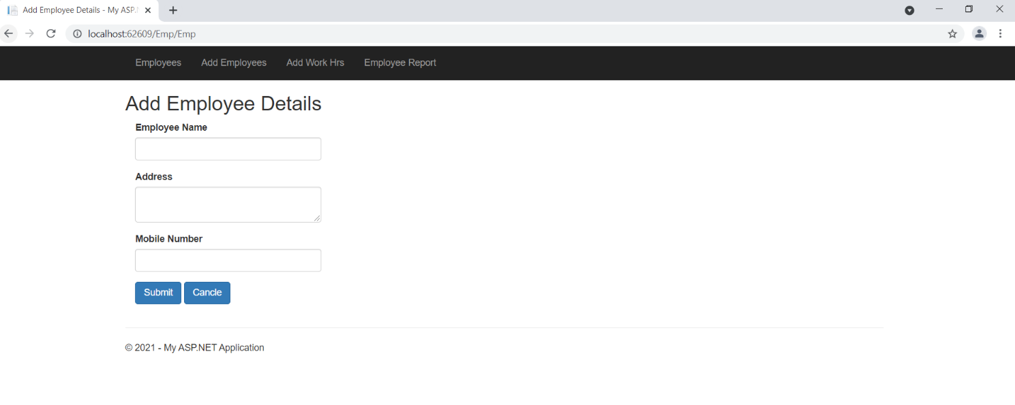

1. Employee List

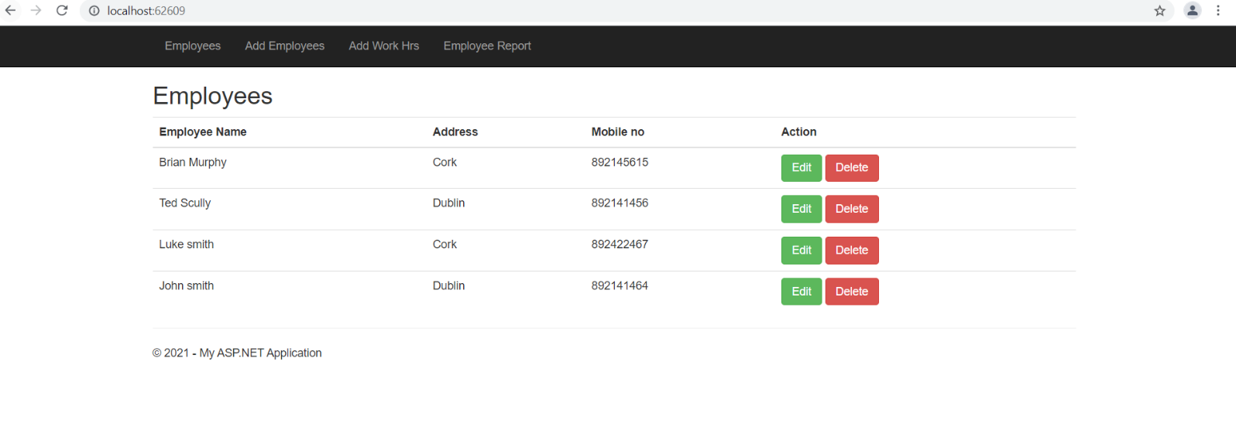

1. Add work details

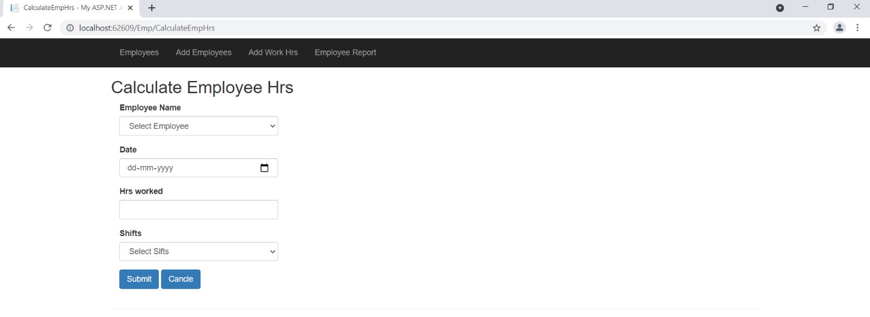

1. Employee Report

